Digital Transformation Program

Program Communication Framework

Jogi Nijjar
Project Management Office
January 10, 2020
Contents
Purpose 3
Program Management Meetings 3
Program Management Communications 5
Program Management Communications Guidelines 8
Program Status Tolerance Scale 9
Escalation Process 9

Purpose
This Program Communications Framework describes how information about the Program will be gathered, consolidated, reviewed and distributed to the Program stakeholders.

Program Management Meetings
Following are explanations of the meetings outlined in the Program Communications section of the Program Charter:
Program Kickoff Meeting
- The Program Kickoff Meeting aims to provide an overview of the Program, strategic linkage, scope, Program roadmap and scope, high level timelines, key risks, key issues, key assumptions, key dependencies, impacted stakeholder groups, costs and any other key information about the Program in order to engage all Program stakeholders around the Program vision and objectives;
- Onboard Partners (Vendors) into the program and as part of planning alignment;
- Depending on the Program team size, there might be multiple instances of the Program Kickoff Meeting.
Executive Steering Committee Update Meeting
- This meeting aims (but not limited) to provide Program status update, key achievements, key dependencies, key risks, key issues, change requests, decision requests and any other relevant information about the Program to the Executive team providing oversight to the Program. A Terms of Reference (TOR) will be setup accordingly.
Executive Sponsors Update Meeting
- Program Owners and Executive Sponsors meet on a regular basis to discuss status, escalated risks, issues, resources, amongst other key updates about the Program.
- Review and approve or decline Program Change Requests above the Program Owner’s authority level.
- Agree to content for Executive Steering Committee meetings.
- Prepare communication updates on the project to the Executive Steering Committee and/or Board of Directors.
- Review financial forecast to actuals in preparation for status reporting to the Executive Steering Committee.
Program Advisory Group Decision Meeting
- These meetings aim to discuss business process, applications and any change that may require input and subject matter expertise from other groups. These meetings may also be used to review and gather recommendations about specific Program risks, change requests, decision requests, issues and dependencies.
- The membership of this group is dynamic as different stakeholders may be required depending on the recommendation and/or feedback required throughout the life of the Program and its project phases.
Program Owners Status Update Meeting
- Program Manager, Project Managers (as/if applicable) and Program Owners will review status, plans, schedules and forecasts.
- Identify and discuss issues or risks to be escalated to the Sponsor Oversight Group and/or Executive Sponsors, and/or the Executive Steering Committee.
- Review financial forecast to actual costs and any other relevant information about the Program status.
Partner Status Update
- Weekly meeting with the Program Management team (CWB Program Manager, CWB Project Manager(s) and Digital partners’ project managers) and Program Owners to review status, plans, schedules, and forecasts and discuss issues, risks, and dependencies that may impact the deliverables aligned with each Digital Partner and the overall Program.
Sprint Planning
- This Program uses Scrum as the delivery methodology. The Sprint Planning meeting aims to review with all Program team members the goal for the sprint, features to be enabled/delivered at the end of each sprint as well as dependencies.
- The Program Owners may be required to attend these meetings to help prioritize the sprint backlog items to be developed throughout the sprint.
Daily Scrum
- These are 15-minute meetings to occur on a daily basis, preferably first thing in the day and always at the same time. The intent of these meetings is to review the progress made by each team member, obstacles and next steps.
- The Program Management team (CWB Program Manager, CWB Project Manager(s) and Digital Partners’ Project Managers) will facilitate these meetings and will be accountable to remove obstacles identified by the Program team.
Sprint Review and Retrospective
- At the end of each sprint, the Program team, Program Owners, Program Management Team and Sponsor Oversight Group (as/if applicable) will meet to review the achievements of each sprint. A workable solution should be delivered at the end of each sprint so the stakeholders can see what has been delivered by the Program team at the end of the sprint (a workable solution does not necessarily mean a production-ready product).
- These meetings also aim to discuss what went well and what needs to be improved for the next sprint, so the process can be adjusted accordingly. Ideally, these items should constitute the lessons learned for the Program and should be documented at the Closure report.
Program Team Status Update Meeting
- On a regular basis or whenever required, the Program team can meet to review specific agenda items that couldn’t be addressed/resolved in the Sprint Planning, Daily Scrum and/or Sprint Review meetings.
Deliverables Review / Approval Meetings
- These meetings aim to walk stakeholder through key sections of the Program Management and technical deliverables that require formal sign off. Ideally, the deliverables to be reviewed and approved must be sent out to all stakeholders in advance for review/preparation. If the stakeholders are satisfied with the content of the deliverable, these meetings may not be required.
PMO Oversight Meeting
- Weekly meeting between Program Manager and PMO to ensure the project is adhering to the program objectives, goals, quality plan, and best practices.
PMO Dependencies and Risks Meetings
- Monthly meetings with all Program and Project managers in the PMO to discuss cross-project dependencies, risks and lessons learned.

Program Management Communications
Program communications will be formalized through the distribution of the following key project communication deliverables (this is not an exhaustive list and refers to Program communications only. Communications to the broader CWB staff base and customers will be managed by the People First teams assigned to the Program):
Content | Purpose | Audiences | Responsible | Timing  or Periodicity | Methods
Initiation/ Start-up Meeting (Optional) | Communicate Program Charter and Program Management Plan | Executive Sponsors and Program Owners | Program Manager | Initiation Stage | Presentation and Workshop
Program Kick-off | Program Kickoff | Executive Sponsors, Program Owners, Program team members, Program Management team and Digital Partners | Program Manager | Initiation Stage (or as needed to engage new phase scope and teams) | Presentation and Meeting (multiple meetings may be required given the size of the audience)
Executive Steering Committee Update | Communicate about overall program status, key achievements, key risks, key issues, key dependencies, key change requests, key decision request and any other topic that requires Executive attention and direction | Executive Sponsors, Executive Steering Committee, and Program Owners | Program Manager | Monthly (or when required) | Presentation and Meetings with Agenda and Minutes
Executive Sponsors Update | Communicate about overall program status, key achievements, key risks, key issues, key dependencies, key change requests, key decision request and any other topic that requires attention and direction from the Executive Sponsors. Typically, these meetings also happen to refine the agenda for the Executive Steering Committee meetings | Executive Sponsors, and Program Owners | Program Manager | Monthly (or when required) | Program Status Report and Meetings with Agenda and Minutes
Program Advisory Group Decision Meeting | Discuss business process, applications and any change that may require input and subject matter expertise from other groups. These meetings can also be used to review and gather recommendations about Program risks, change requests, decision requests, issues and dependencies | Program Owners, Program Advisory Group, Program team members, Program Management team and Digital Partners | Program Manager | Monthly (or when required) | Presentation and Meetings with Agenda and Minutes
Program Owners Status Update | Weekly review of the overall Program status, including key Program log items and risks. | Program Owners | Program Manager | Weekly | Program Status Report, Meetings with Agenda and Minutes
Partner Status Update | Weekly meeting with the Program Management team (CWB Program Manager, CWB Project Manager(s) and Digital partners’ project managers) and Program Owners to review status, plans, schedules, and forecasts and discuss issues, risks, and dependencies that may impact the deliverables aligned with each Digital Partner and the overall Program. | Program Management Team and Digital Partners’ PMs | Program Manager | Weekly (or when required) | Program Status Report, Project Status Reports (if applicable), Digital Partners’ Status Reports,  Meetings with Minutes
Sprint Planning | Review sprint backlog items, technical dependencies, responsibilities and risks | Program Owners, Program Management Team, Program team (delivery leads), Digital Partners’ PMs and other resources that may be required | Program Manager | At the beginning of each sprint | Product Backlog, Sprint Backlog, BRDs and any other document required (to be identified and provided in advance for preparation). Meetings with Minutes.
Daily Scrum | Review of progress from each team member, obstacles and next tasks | Program Management team, Program team (delivery leads), Digital Partners’ PM and other resources as required | Program Manager | Daily | Sprint Backlog and Program logs
Sprint review and retrospective | Review of the work completed during the Sprint and discuss what went well and what needs to be improved for the next Sprints | Executive Sponsors, Program Owners, Program Management team, Program Team (Delivery leads), Digital Partners’ PM and other resources as required | Program Manager | At the end of each Sprint | Workable solution, Sprint Backlog, Test results and any other deliverable required for preparation.  Meetings with Minutes.
Program Team Status Update | Discuss technical risks, issues, dependencies and any other topics that cannot be addressed in the meetings described above. | Program Management team, Program Team (Delivery Leads), Digital Partners’ PM and other resources as required | Program Manager or Project Manager | Weekly (or as required) | Program/Project logs and status reports. Meetings with Minutes.
Deliverables Review / Approval | Review key points of Program Management and/or technical deliverables to secure formal approval | Executive Sponsors, Program Owners, Program Management team and other resources as required | Program Manager or Project Manager | As required | Deliverable to be reviewed and formally approved as well as notes from individual reviews/preparation. Meetings with Minutes.
PMO Oversight | One on one meetings with the PMO leadership team to discuss Program status, key risks, issues, dependencies, costs, CWB’s Integrated Delivery Methodology or other topics. | PMO Leadership team (Sr. AVP, PMO and/or AVP, Program Management) and Program Manager | PMO Leadership team (Sr. AVP, PMO and/or AVP, Program Management) | Bi-Weekly | Program Status Report
PMO Dependencies and Risks | Meetings with the PMO team to primarily focus on portfolio risks, dependencies and lessons learned. | PMO team | AVP, Program Management | Monthly | PMO Consolidated Project Log

Program Management Communications Guidelines
Program communications will be formalized through the distribution of the following key Program communication deliverables (this is not an exhaustive list):

Deliverable | Owner | Audience | Frequency
Meeting Agendas and Supporting Documentation | Program Manager (or delegate) | To be determined based on the required audience for each meeting | For Steering Committee, meetings with Sr. Leadership, regularly planned meetings and/or large group meetings (5+ attendees):  Agenda and materials are make available to all attendees, at least, 2 business days prior to the meeting (as per CWB's meeting protocol).  For planned small group meetings (3 - 4 attendees):  Agenda and materials are make available to all attendees, at least, 1 business day prior to the meeting.  Emergency meetings/ad-hoc meetings/one-on-one meetings:  Rules above should be observed and followed as possible, but these meetings don't count for the PMO SLOs. A brief agenda is always required so attendees understand the purpose of the meeting.
Meeting Minutes | Program Manager (or delegate) | Everyone invited for the meeting | For all recurring Program meetings (e.g., Executive Steering Committee, Weekly Program Owners Update Meetings) and for any Program meetings where key project decisions are made. Minutes should be distributed within 2 business days of these meetings.
Program Status Reports | Program Manager | As previously defined | Weekly
Steering Committee Materials | Program Manager | As previously defined | Monthly (at least, 2 business days prior to the meeting)
Project Kick-off Materials | Program Manager | As previously defined | One time at the end of the Planning Phase of the project
Other reports/dashboards/memos | Program Manager (or delegate) | To be determined based on the information to be communicated in these deliverables | On demand (as/if required)

Program Status Tolerance Scale
When reporting Program status information, the following tolerance scale should be used:
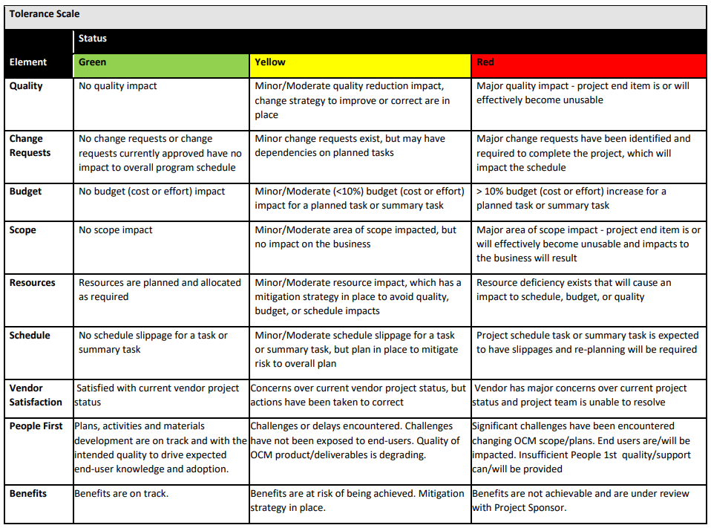

Escalation Process
Escalation means initiating an additional sequence of actions over and above the normal process flow that is required to release a “blockage” or solve an “issue” to achieve a particular objective; in most cases, involving management levels above an individual to facilitate the resolution.

Typical Situations Requiring Escalation:

- Resource conflicts – to secure, retain, and engage the most appropriate resources for the Program’s needs.
- Inter-group conflicts – stakeholders disagreeing over critical issues or priorities that need a relevant authority to mediate and facilitate resolution.
- Incorrect expectations about roles and responsibilities – to seek clarity in disputes related to roles and responsibilities as seen by different stakeholders.

The sequence of escalations:
1 - Project Manager (if applicable)
2 - Program Manager
3 - Program Owners
4 - Further escalation will be at the discretion of the Program Owners

